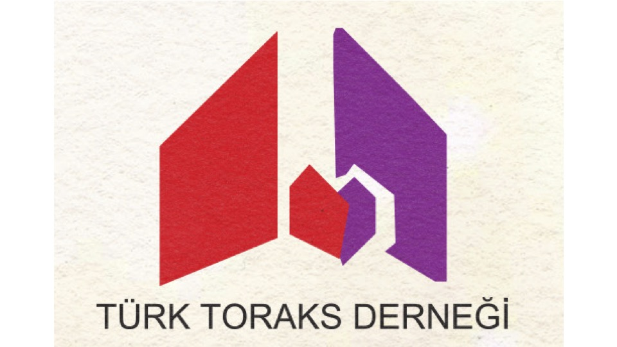 |  | 
PULMONOLOGY JOINT MEETING
Türk Toraks Derneği & Österreichische Gesellschaft für Pneumologie
Vienna, Austria | 11 – 14 June 2026
Hotel Best Western Plus Amedia Wien

Organizing Committee
Caglar Cuhadaroglu (TTD President)
Eveline Kink (ÖGP President)
Irene Czurda
Dorina Esendağlı
Nilüfer Aykaç
Ezgi Demirdöğen
Çağla Khursuhd Huseyinova

